Design of Magnetic Tweezers for Measuring Forces

Team: D
Mohammed Zuned Desai
Areio Hashemi
Koji Hirota
Michael Wong
Dr. Sharad Gupta
Dr. Valentine Vullev
Bioengineering 175B – Senior Design
University of California, Riverside

Table of Contents
- Abstract
- Project Objectives
- Background
- Prior Art Review
- Functional and Performance Specifications
- Block Diagram of Problem
- Evolution of the Final Design
- Detailed Description of Final Solution
- Materials Section
- Method of Prototyping Discussion
- Performance Testing Protocol Discussion
- Performance Testing Results Discussion
- Financial Considerations for the Design
- Conclusions
- Future Work
- Statement of Societal Impact
- Appendix I: List of Abbreviations
- Appendix II: Project Budget
- Appendix III: List of Equipment and Facilities
- Appendix IV: Team Job Responsibilities
- Appendix V: Detailed Design Drawings
- Appendix VI: Testing Results
- Appendix VII: Single-Molecule Force Spectroscopy
- Appendix VII: References

Abstract
Magnetic tweezers are scientific instruments used for studying molecular and cellular interactions. Their functionality resides in their ability to measure forces on a particle using a magnetic field gradient. They are one of the most commonly used force spectroscopy techniques and are specifically employed to study force regulated processes in biological systems. This is primarily due to the fact that they can provide good resolution without exerting thermal or physical damage to the biological sample. Our design will incorporated facets of the previous senior design group consisting of George Ibrahim and Co, this group dealt with the calibration of the magnetic tweezers design and likewise they were able to measure forces of up to 10pN. Our groups overall goal is to design a magnetic tweezers device that is capable of obtaining force measurements up to at least 100 pN because we know many interactions in the body are around that range. Furthermore, our perfected design also implements a new bright field transmission microscopy which we hope will generate better quality images.
Project Objectives
The main objective in our project is to design and build magnetic tweezers that is comprised of two magnets that can achieve forces of up to 100pN. This will allow us to study interaction properties between two species such as proteins, ligand etc. Our project is a continuation of the 2008-2009 senior design group D at University California Riverside. However, the difference lies in the fact that their focus was more of on the calibration of the device as well as utilizing it to study molecular interaction. Our goal is to improve upon their design by fabricating one that is capable of achieving a force up to 100pN this is because under a 100pN we can’t see the dissociation of enzyme inhibitor complex. This differs from last years senior design group which could only produce up to 10pN. In order to complete this objective we will divide it into three sub goals as follows:
- Use Finite Element Method Magnetics (FEMM) to predict and design geometry of the magnet alignment that will produce the field gradients that can hopefully produce forces that can achieve up to 100pN. (A description of FEMM will be given later on in the Evolution of the Final Design section).
- Machine and assemble the magnetic design created from the FEMM calculations. As well as setting up the entire apparatus along with the microscope, mirror, CCD camera etc. for image acquisition.
- Calibrate the Magnetic Tweezers setup using procedures previously developed by George Ibrahim and Co. to determine the forces the system can achieve as well as preparing the setup so it is ready for data acquisition.
Background
Magnetic tweezers is a research tool for studying molecular and cellular mechanics. Simple models of magnetic tweezers consist of a pair of magnets that are placed on top of the sample holder on an inverted microscope. They are capable of applying forces of over 1nN. In addition, they are able to rotate and control the magnetic particles up to 5um. A magnetic particle in the external magnetic field experiences a force that is proportional to gradient of the magnetic field squared. As a result even when the magnets have a relatively small magnetic field, they can still produce a high force if they have a steep gradient field. However there are several drawbacks of magnetic tweezers, these include the fact that a considerable amount of force can only be applied to the sample near the magnet. This is due to the reason that the force decreases dramatically as the distance increases from the magnet. However, even if the sample is in close proximity to the magnet the force exerted on the sample is not always constant. In addition, magnetic tweezers are not very flexible. This is due to the fact that the magnets are put in a permanent configuration and moving it around will prove to be troublesome. The measurements are also limited by the video-based detection, so if the particles are very small or they move extremely fast it will then be difficult to obtain results. Finally, in order for magnetic tweezers to produce a high field gradient it requires high-current electromagnets which could produce a lot of heat or require small closely space pole pieces which would then eliminate the property of the magnetic tweezers to provide a constant force for the magnetic particle. Despite the drawbacks, there are still many applications and advantages for the use of magnetic tweezers. These applications include using noninvasive forces to measure displacement in intricate environments such as the interior of cells. This is because magnetic tweezers will not cause the sample to overheat as in other similar instruments (optical tweezers) hence will not damage the sample. In addition, since the magnets are placed in a permanent configuration, the components become easier to assemble and combined with forced clamp properties it will give the tweezers the ability to rotate and this will be well suited for the use to study DNA topology topoisomerases.
Our goal as mentioned before is to hopefully make Magnetic Tweezers that can reach 100pN. This means that our magnet needs to produce a stronger field gradient than last years senior design group. We need a strong field gradient because the beads are super-paramagnetic, this means that they have dipoles that will only orient in the presence of a magnetic field gradient. Hence, the larger this gradient the faster the dipoles will align with the magnetic field and thus generate a greater force output on the beads. Our interest lies finding a strong magnetic field gradient, however we also want this gradient to be homogeneous, which means that the change in the magnetic field gradient is linear (constant gradient). This will provide us with a region that produces a constant force, this force can be calculated by measuring the velocity at which the super-paramagnetic beads move over a given distance. This is how we determine the force exerted on the beads and ultimately determine the force interacting on molecules.
In the case of business opportunity aspects, the final product that we will design can be marketed more towards Universities, Research Institutes, Biotech Companies and Laboratories. It is not intended for the average person as it requires above average knowledge of this field. This cliental restriction is not a limitation rather we foresee it as a potential solution to two major problems. The first being the fact that device itself must be calibrated before its used, which implies the person must have some knowledge so they can properly follow the steps in the calibration manual. The second concern deals with budgeting and expenses for the both the buyer and ourselves. The full system contains a video camera, microscope, and our product. If the customer were to buy all of the components it would be far too expensive for their budget. However, for our intended customers they should already have the video camera and microscope thus only needing to purchase our product. This approach cuts their costs and also allows us to make a profit.
Prior Art Review
There is a similar project of magnetic tweezers that is done by George Ibraham and Co. This group focused more of their effort on the actual calibrations of the device rather than being concerned with the parameters of the magnet. They used a trial and error technique to obtain their respective results until it aligned with what they expected. Furthermore, they assumed that the flat 180º shape of the magnet will produce the strongest magnetic field gradient. Our group will be experimenting with different shapes and angles of the conical tip that will potentially give us a better field gradient than that of the flat shape and implement this change into our design. In addition, their project did not have a bright-field transmission so we will also have to incorporate that into our design. However, the work done by George Ibraham and Co. did have a well defined protocol to calibrate the magnetic tweezers and has a feasible design enabled them to attain a force of up to 10pN. Also, their magnetic tweezers had a temperature control, current control in electromagnet up to 12V, using of 10x objective lens, applying Kimwipe to prevent LED light to overexpose the samples, and making the magnetic sample beads by using PDMS (polydimethlysiloxane) which had the components ration of base 10 to 1 agent. In any case we do plan on using their calibration methods on our finalized design.
Another product that is similar to ours is something called the hybrid magnetic tweezers which are invented by The Regents of the University of California (Oakland, CA). The inventers are David E. Humphries, Seok-Cheol Hong, Linda A. Cozzarelli, Martin J. Pollard and Nicholas R. Cozzarelli. This hybrid magnetic tweezers apparatus is primarily developed for biotechnological applications such as capturing, separating, holding, measuring, manipulating and analyzing micro and nano-particles and magnetizable molecular structures. Their hybrid magnetic tweezers are a combination of permanent magnets and soft ferromagnetic pole materials. Their hybrid magnetic tweezers are built as mirror images that are single or multi-pole hybrid magnetic structures. This structure includes a non-magnetic base, wedge-shape of notch or concavity ferromagnetic pole tips, and two blocks of permanent magnet material which is built onto the non-magnetic base as opposite sides of and adjacent to the ferromagnetic pole in a periodic array, and the magnetization orientations of the blocks oriented in opposing directions and orthogonal to the height of the ferromagnetic pole. The material of this non-magnetic base is aluminum, the ferromagnetic pole is made of steel, and the permanent magnet materials are a rare earth element such as neodymium iron boron or samarium cobalt. It can be seen from their hybrid magnetic structure, that their device can exert a magnetic field strength of approximately 0.6 Tesla to 1.0 Tesla. This enables their hybrid magnetic tweezers to exert a force on a target bead approximately 1 nN to 10 pN. These hybrid magnetic tweezers are applied to a variety of molecular measurements. For examples, this hybrid magnetic tweezers can be used for breaking DNA molecules by force during chromosome segregation. Also, such a high force produced by this hybrid magnetic tweezers can be useful to monitor the movement of motor proteins such as chromosome segregation by kinesins on microtubules during mitosis and meiosis.
Regarding the patent search, the hybrid magnetic tweezers produced by the Regents of the University of California which was introduced above has several claims. Their hybrid magnetic tweezers has the structure of the paired mirror image of hybrid magnetic. Each of the hybrid magnetic structures has non-magnetic base (made of aluminum) and a ferromagnetic pole (made of steel) having a wedge-shaped tip which characterizes a notch or concavity in cross section to concentrated magnetic filed in interest region. This notch has about 0.5mm in depth in cross section at the tip. This hybrid magnetic tweezers are able to change its tip shape from 0 to 90 degrees angles relative to the ferromagnetic pole and the magnetic field strength in the region of interest at least of 1.0Tesla. Further patent search will be accomplished. This hybrid magnetic tweezers have a clevis structure which is a multi-walled housing that the hybrid magnetic tweezers are mounted. This clevis shape makes it possible to apply the magnetic field force from various three-dimensional orientations and positions. The sample target beads should be magnetized molecules or particles. These are the claims that they have for this hybrid magnetic tweezers for which they have obtained a United States Patent 7474184 . Another interesting fact from our search is that we found many other products which have the similar functions to our project. However, the methodology of their operations is not concise and clearly though out something we hope to perfect in our senior design project.
Functional and Performance Specifications
Our final design will be composed of a 10x objective lens that is placed underneath the slide that is held by the stage manipulator which can be moved in both the vertical and horizontal axis to our magnet via a small dial located on its end. The sole purpose of this movement is so that we are able to achieve our desired distance from our slide to the magnet. This slide containing our PDMS sample will be placed on a stage that consists of two poles located equidistance from the objective lens, thereby leaving enough room for the image acquisition and yet not sacrificing stability. The magnets we will be using are 12V electromagnets meaning that the max voltage that we can apply is 12 volts, any more and we run the risk of overloading the magnet. Our magnets will be hooked into a DC power supply from which we will be able to control the amount of current and voltage going to our magnet. Imaging was obtained by placing a mirror below our objective lens, this mirror was placed at an angle so it could reflect the image on the slide to the CCD camera. The placement of the flashlight that will enable us to produce bright field transmission microscopy images was placed directly above our two magnets thus not interfering with anything.
The preliminary physical test runs that we preformed to verify certain trends obtained from our FEMM runs had a similar setup. This design setup consisted of a single 12V electromagnet that was also hooked on to a DC power supply. The magnet was held by a horizontal stage clamp that was attached to a base capable of maneuvering in the horizontal direction. Also utilized was a magnetometer probe 4mm in diameter and 2mm in thickness, this probe was used to calculate the magnetic field obtained when we applied 12 volts with 0.1 amps. In order for accurate measurements we fitted the probe on to a glass slide and attached it to a movable stage capable of motion in all direction.

Block Diagram of Problem
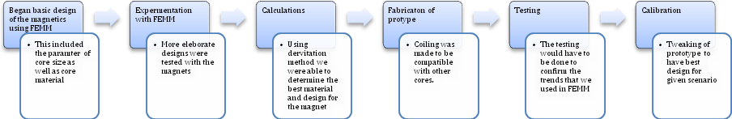
Evolution of the Final Design
In order for us to come up with a final magnet design that can achieve up to 100pN we will be using a program Finite Element Method Magnetics (FEMM). This is an open source finite element analysis software package for solving electromagnetic problems. The software is good for processing various problems that deal with 2D planar and axisymmetric geometry, magnets, electrostatics, heat and current flow. Its popularity resides in its simplicity as well as accuracy all the while having a low computational cost. Furthermore, it has been referenced in several journals and used by several reputable societies like IEEE and UK Magnetics.
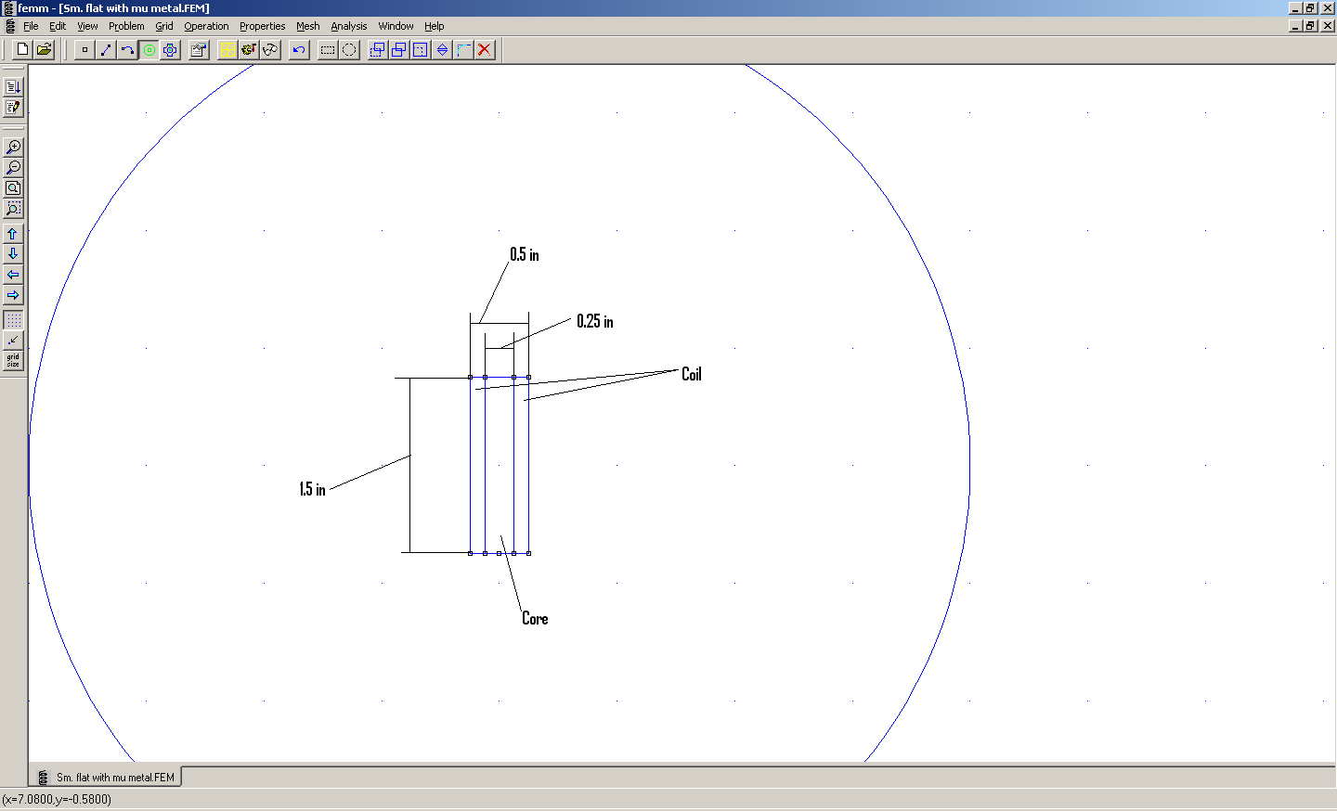
Figure 1: Sample FEMM Model before a simulation is ran
This is the sample run that describes what FEMM program simulation is (Figure 1). We specified the dimensions of the magnet including the core size, number of coiling turns, the coiling size, and material of core and coils. After completing the design specifications, FEMM program simulates the behaviors of the magnetic field generated by given inputs and estimated calculation data of magnetic field. Figure 1 shows the sample of the FEMM diagram before we ran the simulation.
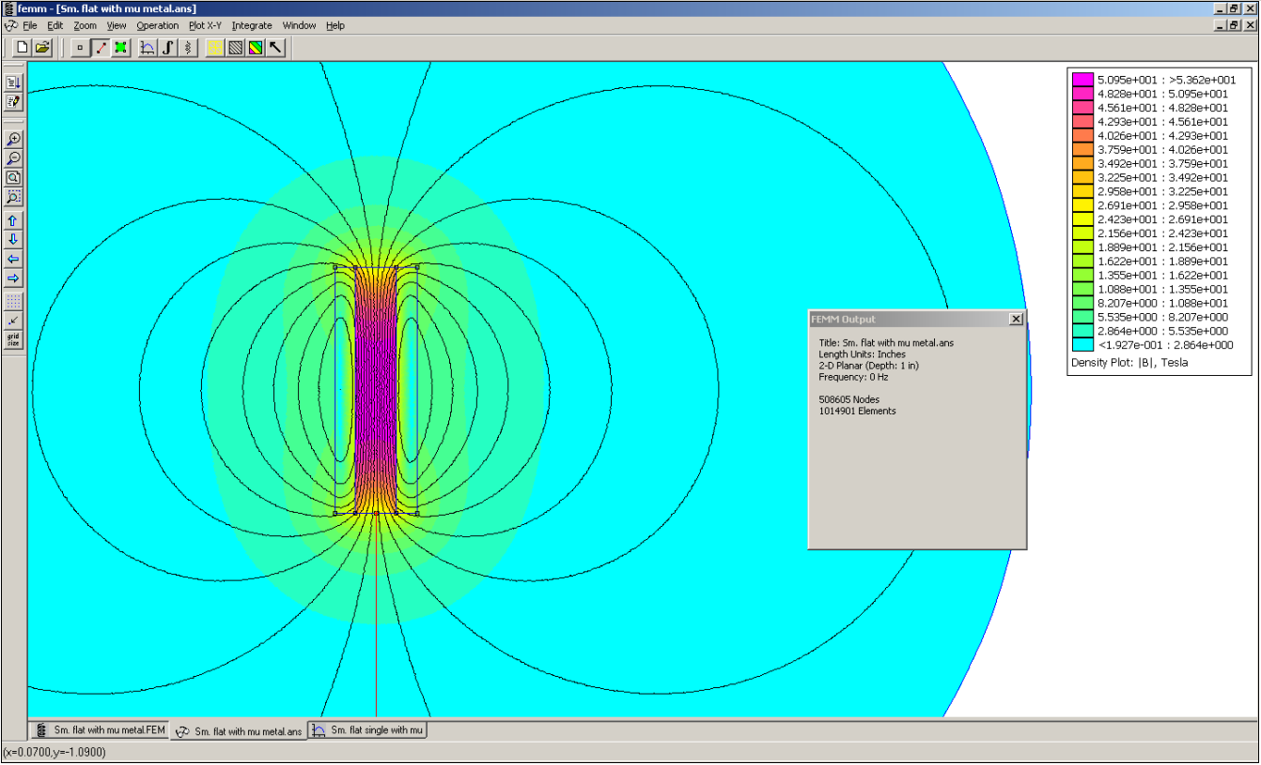
Figure 2: Sample FEMM Model after a simulation is ran
Here we have a sample FEMM screen shot after we ran the simulation. The colored area shows the field strength, and we want the highest field strength away from the tip. The read line is a tool in FEMM that allows us to measure the field strength of the magnetic field produced by our simulated magnet away from the tip. In our calculations we will be measuring field strength 1.5 inches away from the tip because that is usually the working distance of the tweezers and any distance further than that will not be a concern for us. The data of the field strength is then exported to a text file.
The data we obtained from FEMM program simulation is analyzed by using IGOR program. IGOR program is commonly used for extensible scientific graphing, data analysis, image processing and programming software tool. We use IGOR program because it is an extraordinarily powerful tool that is not complicated to work. By using IGOR program, we utilize the text file to graph the magnetic field strength with respect to distance from the magnet tip and then we took the derivative of that to get the gradient, which is what we want. This is because the gradient signifies change of the magnetic field and the change can be calculated by taking the derivative. After that we compared the graphs of different models to determine which one gave a greater magnetic field gradient and used that information to develop a final design of the magnet. Please keep in mind that although we are using FEMM to simulate models of our actual design the values generated is not concrete we are merely looking at the trends rather than the actual values.
Material Testing (Core)
The first simulation that we did was to test for the material of the core. We ran the simulation for two different materials; iron and mu metal. We choose these types of metal because the iron is the current material and mu metal is what we want to look at.
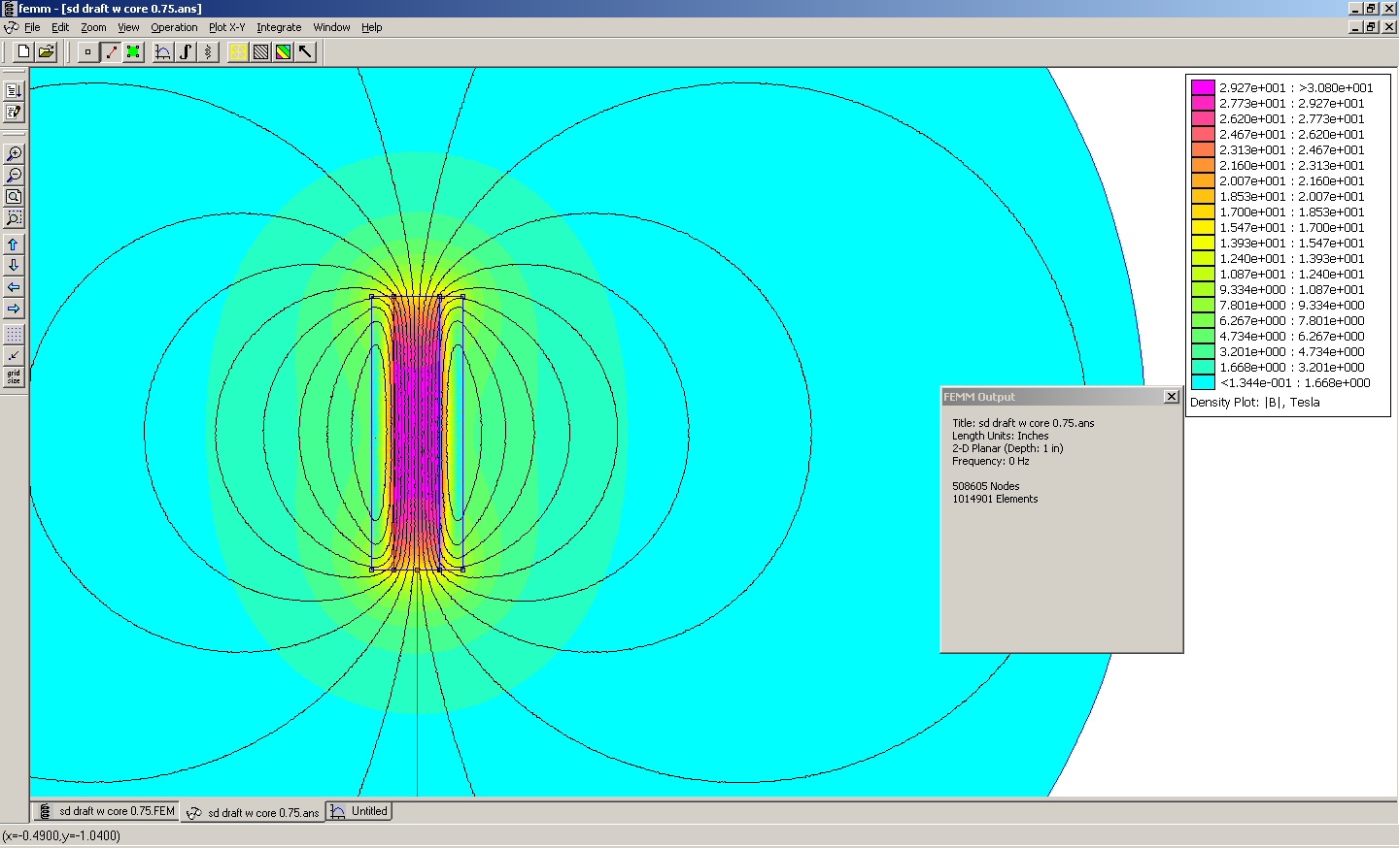
Figure 3: FEMM model of iron

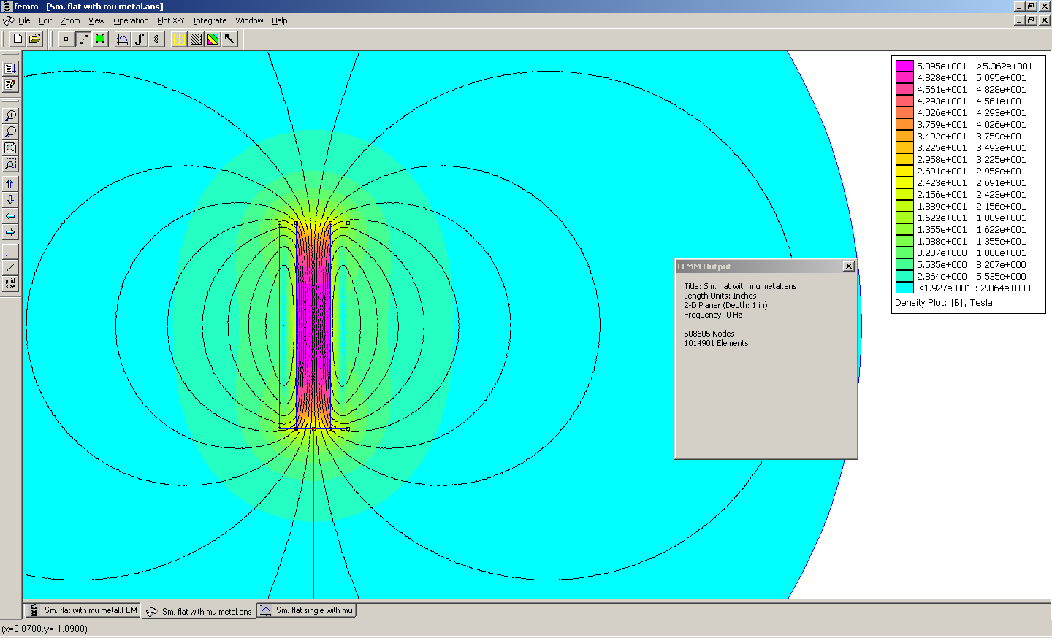
Figure 4: FEMM model of mu metal
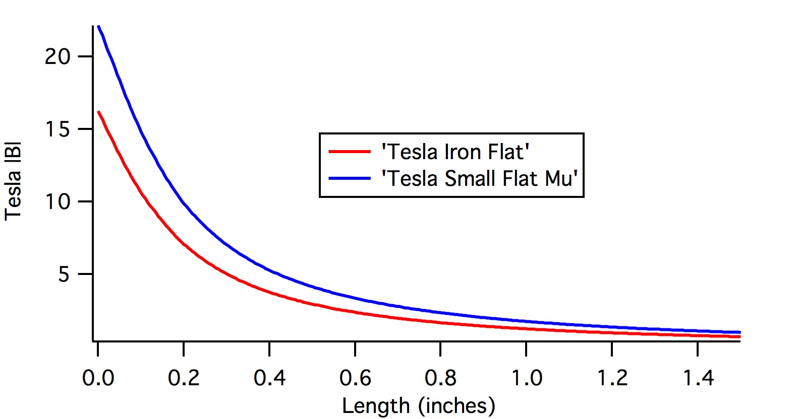
Figure 5: Magnetic field strength vs. Distance
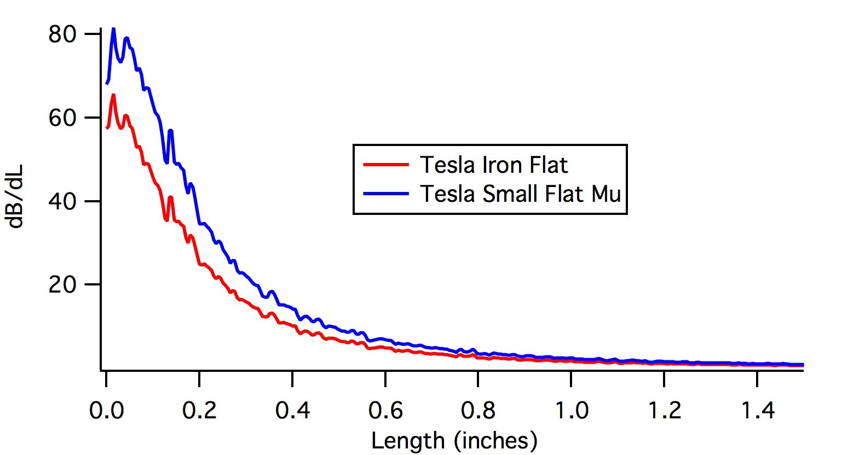
Figure 6: Magnetic field gradient vs. Distance

Data Analysis:
After we ran the simulations of the different metals we measured their magnetic field strength and then took the derivative (gradient) of the data point. We then used it to determine which material gave a better gradient and from the graphs and as seen from figure 6 we can say that the mu metal produces a stronger gradient than iron until it reaches around 0.8 inches from the tip where both materials both have similar gradients. This is fine because the working distance of the magnet and tip is generally between 0.2 inches to 0.6 inches. From this we concluded that the material of the core should be made from mu metal so for the following simulations we will be using mu metal for the material of the core.
Shape of Tip Testing

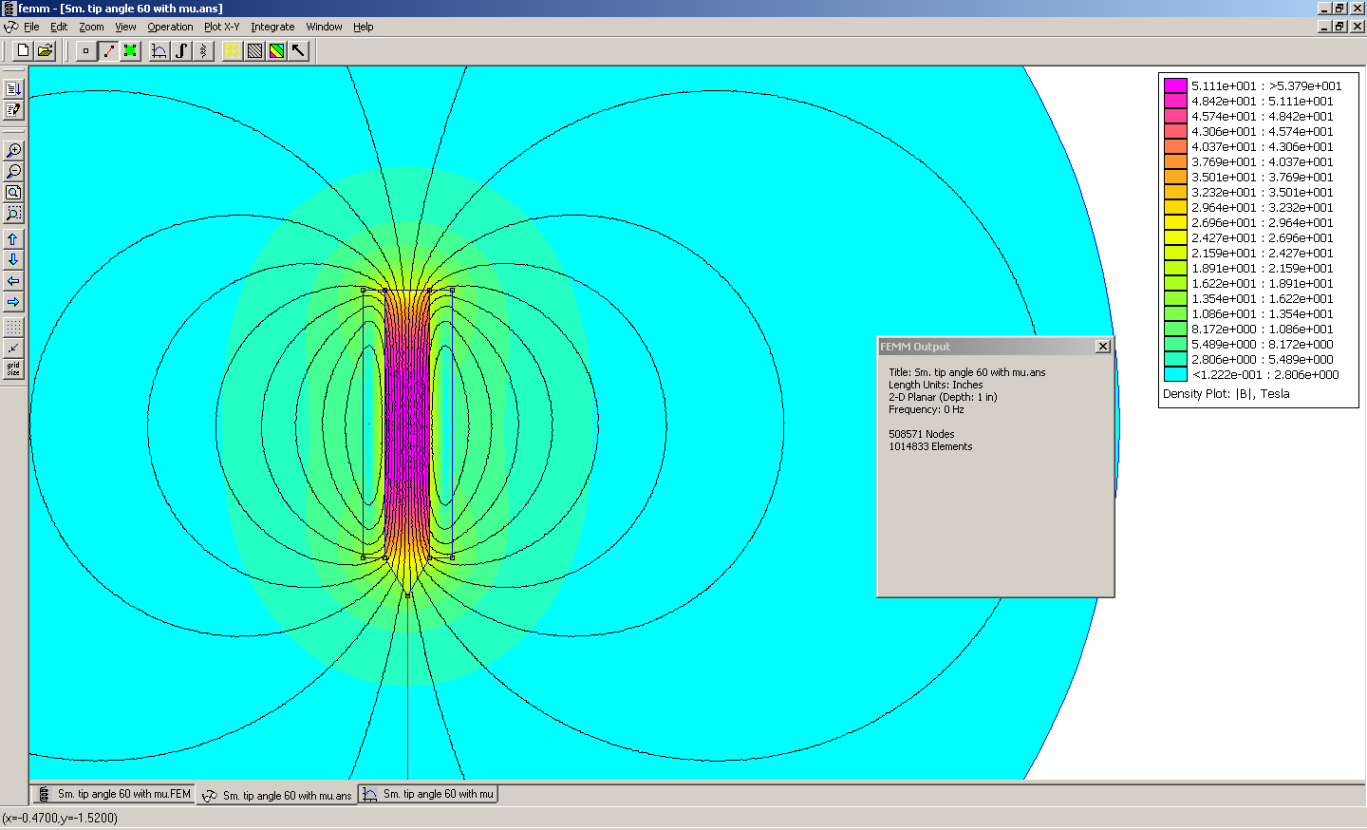
Figure 7: FEMM model a pointed tip at 60⁰ of mu metal
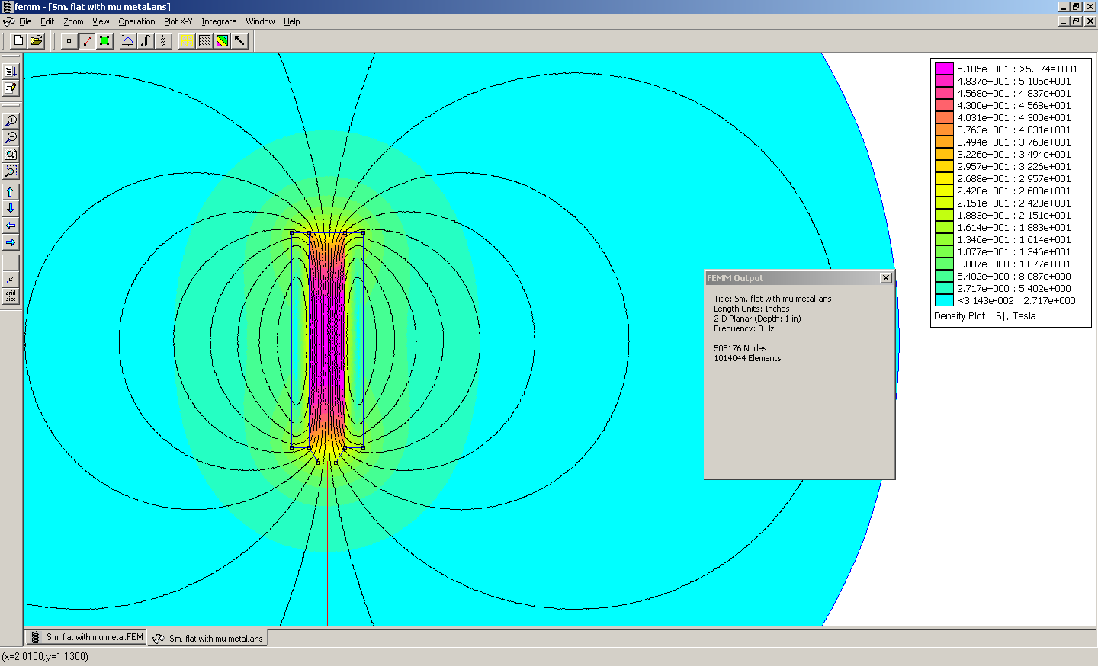
Figure 8: FEMM model a pointed angle flat-tip of mu metal
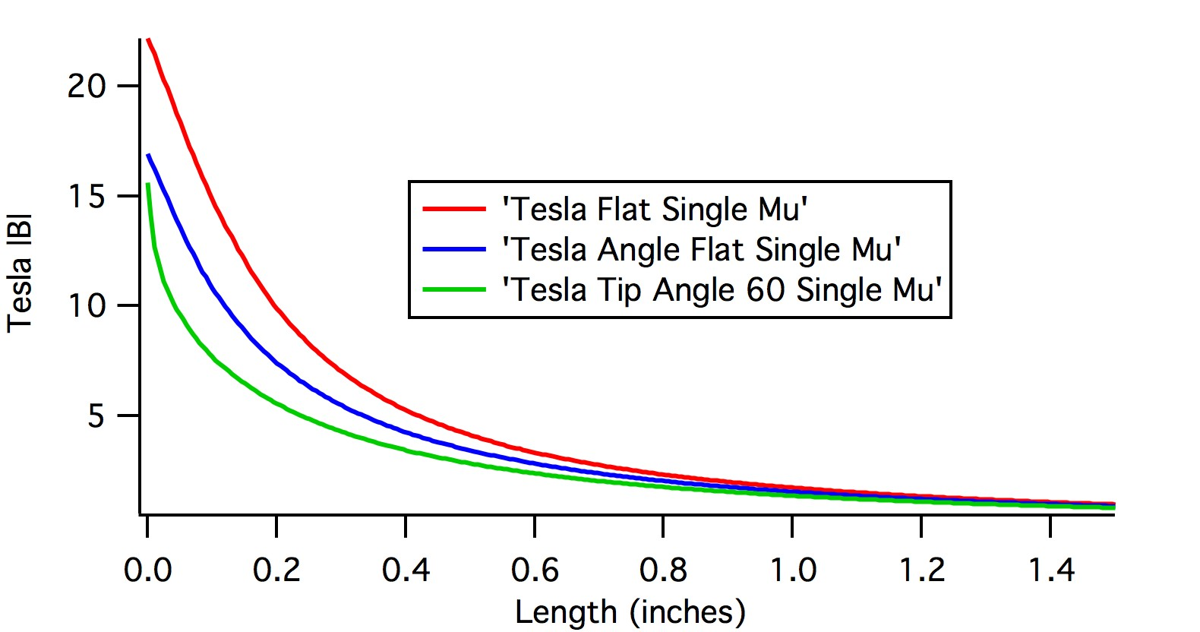
Figure 9: Magnetic field strength vs. Distance for the tip testing

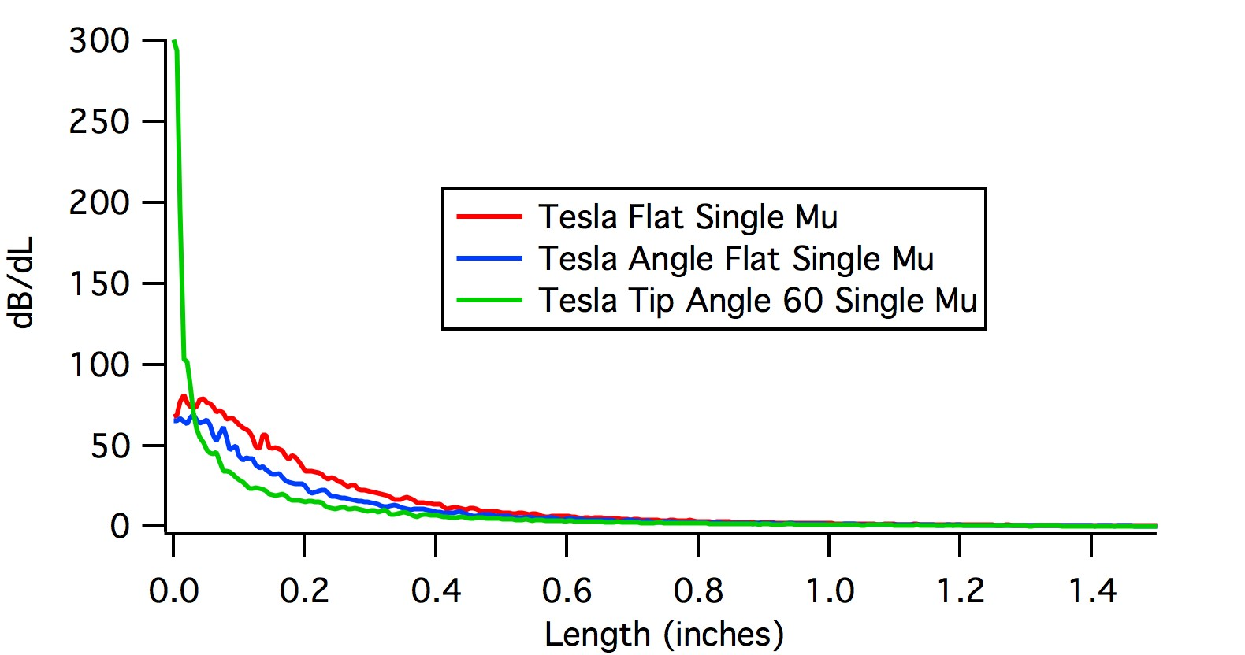
Figure 10: Magnetic field gradient vs. Distance for the tip testing
Data Analysis:
After we decided the mu metal was the better material for the core we then tested different shapes of the tip to see which shape would produce higher field gradient. As seen from figure 10 it seems that the flat mu metal (figure 4) gave the better results. Although the tip (figure 7) gave a best magnetic field gradient up to distance of 0.1 inches away from the tip it is not feasible. This is again because the working distance is around 0.2 inches to 0.6 inches from the tip and at such close distance the high field gradient would not be useable. So from these simulations we concluded that the flat mu metal (figure 3) is the better shape of tip and this is what we will be using for the following runs.

Double Magnet Angle Testing
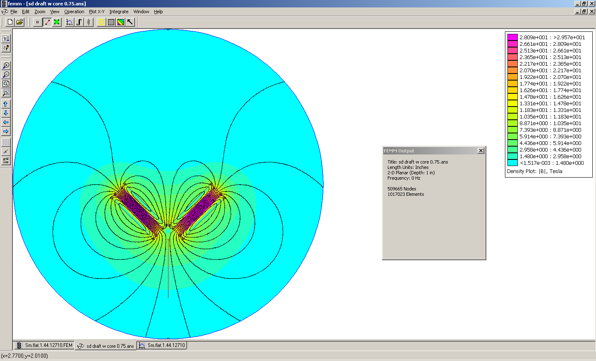
Figure 11: FEMM model of double magnets that is 90⁰ with respect from each other

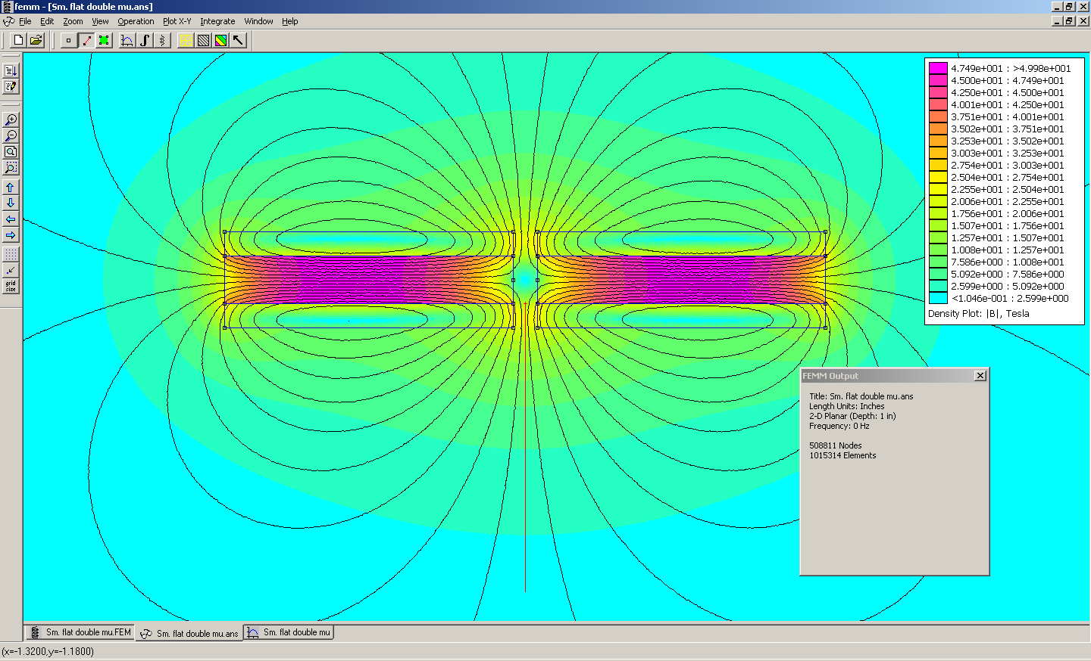
Figure 12: FEMM model of double magnets that is 180⁰ with respect from each other
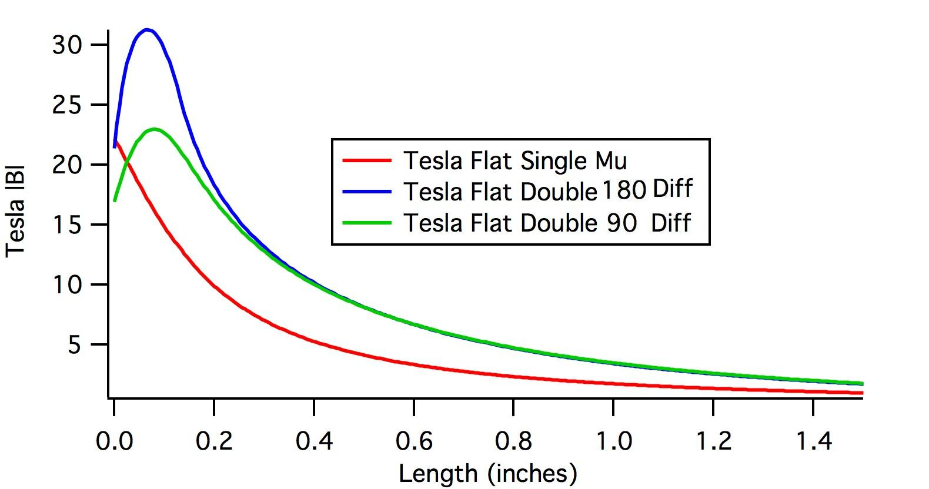
Figure 13: Magnetic field strength vs. Distance for the double magnet angle simulation
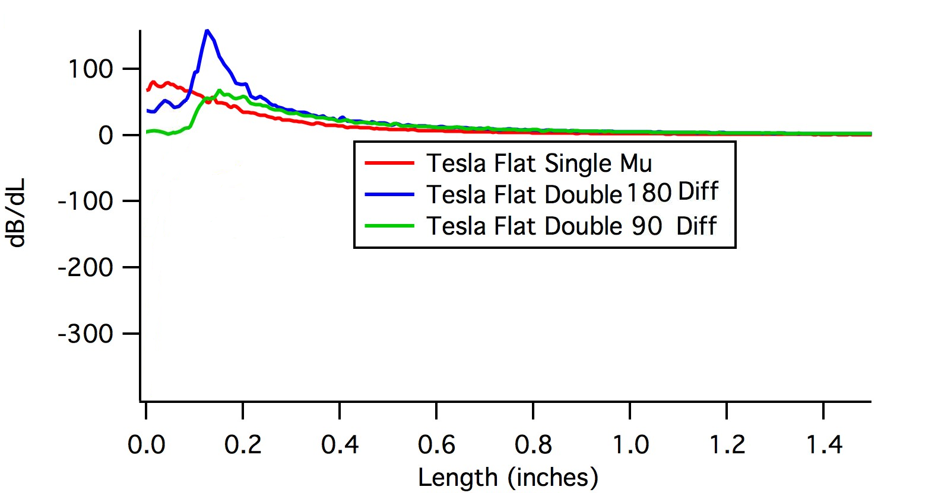
Figure 14: Magnetic field gradient vs. Distance for the double magnet angle simulation

Data Analysis:
Previously we determined that the flat mu metal give the result that produced higher magnetic field gradient. Now we want to incorporate a second magnet because this will allow us to maximize the field strength as well as the field gradient. However we did not know what angle to put them to with respect to each other so we tested it at 90⁰ (figure 11) and 180⁰ (figure 12) with respect to each other. As seen from figure 14 the two magnets with 180⁰ with respect from each other gave the result that produced the trend of the higher magnetic field gradient. This led us to the conclusion that if we were to incorporate two magnets it would be best if we put those 180⁰ from each other. As we can see from figure 14, the single mu flat metal gave a higher field gradient at distances 0 to 0.1inches away from the tip. However again this is not a feasible working distance while the double magnets have a stronger magnetic field gradient at distances 0.2 inches and further which is a good working distance and what we want. Although the 90 degree double magnets also have magnetic field gradients higher than the single mu flat metal it does not match the magnitude of the 180 degree double flat magnets. Another graphical difference between the double and single magnets is with the double magnets there will be a specific region in which the magnetic field gradient will be the strongest. This area is going to be located equidistance from the center to both the respective magnets, hence there will be a bell shaped curve as shown in the figure 13.
Evolution of the final magnet design

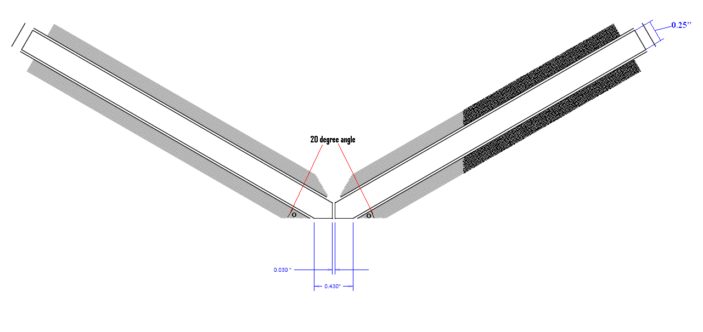
Figure 15: Shows the final design of our Magnetic Tweezers

The double magnet model simulation showed that the best orientation of two magnets is when the tips are flat and the two magnets are 180⁰ oriented from each other. However that was not our final design because if the two magnets are 180⁰ oriented from each other the coil will be in the way of the working area and as a consequence it would prevent the bead from getting close enough from the tip where the highest magnetic field gradient is located. In order to accommodate that problem we will have to angle (20⁰) the two magnets so the coil no longer interferes with the bead while making a sharp tip (for each single magnet) so it still maintains a flat 180⁰ shape at the bottom when the two magnets are put together.

Detailed Description Final Solution (Include calculations and figures)
Materials Selection
Method of Prototyping Discussion
Performance Testing Protocol Discussion
Performance Testing Results Discussion (include statistical analysis for quantitative data)

Financial Considerations for the Design
In terms of business, financial considerations are one of the most important aspects to think about. If the product does not provide a reasonable profit then there is no reason for the product to be made. This is why our product is designed in a way where we can keep the price for the future prospect customers low so that it is affordable to them as well as a reasonable enough cost of fabrication. If the product becomes too expensive to fabricate then in order for us to sell the product the price we have to sell it for will also become quite expensive. However there is usually a tradeoff between the price of the product and the quality. Either we get a better quality of the product for a more expensive price on the fabrication or we get a more mediocre quality for cheaper. This is one of the main financial considerations we had when designing our magnetic tweezers. It was either to build a more expensive pair of magnetic tweezers for a higher price which could exert a stronger force or we could just settle with a less powerful pair of magnetic tweezers and have our budget reduced. In our case we decided to go with the more expensive route on designing the magnetic tweezers. This is because we wanted our setup to be the best that it could be. Our goal of the project it to design a pair of magnetic tweezers that surpasses what was built in the senior design of last year (essentially to get best possible design of magnets that produces a strong force). If we went the cheaper route which was what the group of last year did we would be following their exact footsteps and would possibly cause us not to reach our goal. Hence in order to accomplish our goal we would have to go the more expensive path. This decision mainly came when deciding when and how to do our magnet coiling. We could either have a company who are more familiar with coiling do it for us, or we could coil it ourselves (which was what last year’s senior design group did). By coiling it ourselves we could save possibly up to $300. However many problems could occur when doing it ourselves. 1) We could mess up easy on the coiling and would have redo the process which would mean we have to buy more material due to our lack of experience. 2) We have to coil two magnets identically in order to have the magnets exert the same force in our design; however we have no experience with coiling what so ever, so the chances of us creating two identical magnets are very small.3) The quality of our magnet coiling can also be very bad once again due to not having the correct equipment. When we visited the coiling company we were given a tour of the working area. The quality of our equipment does not even compare theirs. The machinery they had could easily cost over tens of thousands. This could easily result in a fabrication of magnets that is worse than the current design if we were to do it by ourselfs. Taking these problems into consideration we decided to have a company do the coiling for us as these problems outweighs the price that they charge, because if any of these problems were to occur, our work for the two quarters would have been a failure. Thankfully, all the other expensive equipments, including the inverted microscope, CCD camera, stage, DC power supply, and the tweezers assembly parts etc. had been purchased already so in our budget we did not have to worry about buying these parts. Another justification for choosing the better quality design is that students will be using our design for research in the future and their main motive it not to sell the equipment, but to publish respectable papers, so by choosing the better quality design of the magnetic tweezers we would allow them to get more accurate data as well as perform a larger range of data analysis.
Conclusions
Over the course of these two quarters we were able to successfully design and build a pair of magnetic tweezers. During the first quarter we were successfully able to use FEMM to analyze a design for the fabrication of the Magnetic Tweezers. The use of the software to analyze the design of the magnetic tweezers took a longer time than originally expected as we ran into a few problems including that the software did not run for certain simulations. Nevertheless we were able to use FEMM to determine trends of the force the magnet by changing different parameters including the core material, size, the core shape, the coil thickness, the number of turn etc. Although FEMM gave us arbitrary results and it does not match the actual measurements that we took it does not matter. The information we wanted from FEMM originally is not the actual numbers but the trend of the magnetic fields by changing different parameters. By using the trends produced by the software we could determine the general shape and design we could use for building our Magnetic Tweezers. Because the use of FEMM, we were able avoid blindly fabricating our magnet design and going through a trial and error process. We were able to directly build a design in which we believe would give us results that we wanted. However even after producing the design from FEMM there was still the decision of whether to do the coiling ourselves or to have a coiling company do it for us. We decided that we will have a company coil it for us. However, when we choose this route there were several concerns that came up. 1) The budget issue, the cost of the project would increase but this was justified from above in the financial considerations for design section. 2) If we are not coiling the magnet then we are not necessarily “designing” our own project after all the class is called “senior design”. However we can assure you this is not the case. Although we are not necessarily coiling the magnet ourselves, we designed all the other specifications such as the angle of the coils, the number of turns, the thickness, the length, the material etc. We designed and calculated all of those specifications before we sent it in for the coiling company to build and this is where the “design” part comes into play. Another argument for this problem is that our project is to design and fabricate Magnetic Tweezers, but Magnetic Tweezers do not only consist of the magnets but other components as well including the CCD Camera, Microscope, clamp, the stages, poles etc. We have to assemble all these components together in order to say that our project is complete. The coiling of the Mu metal is just part of the magnet component and not the entire setup. An analogy I could use is saying if we coil the Mu metal ourselves is like we should purchase all the parts of the CCD camera separately and then putting the components together to build the CCD Camera which is not a realistic situation as we do not have all the equipment available to do so. These reasons are why we choose a coiling company who has been doing this for over 80 years to do our coiling for us.
During the second quarter we were able to find a respectable company to do the coiling for us and build magnets that matched our design. We are currently in the process of waiting for the magnets to be coiled before we can further advance in our fabrication as well as calibration. To be continued after more work is done.
Future Work
As of this far with the project there are many things we could continue doing with our magnetic tweezers. As far as this quarter is concerned we still have to finish the assembly of our design. After that there is a process of calibration that we have to go through as well as a testing phase to see how well our product works compare to previous senior design group after that then our main goal of the project should be considered complete. However there are many side things that we could do with the magnetic tweezers once the fabrication and calibration is complete. If time permits one of the future works we could do is to do some actual experimentation using our product. Another thing we could implement it some sort of light source for illumination. As of now we there is no illumination of the product right now and if we implement a light source we could help increase the contrast of the images taking by the CCD cameras.

Statement of Social Impact
The building of magnetic tweezers could help lead much advancement in clinical and research applications. As magnetic tweezers is still a relatively new instrument for testing biological interactions there are still a lot of improvements to be made. However the potential of the instrument is also great. This instrument allows us to non-invasively measure force between biological molecules. This is potentially very useful because eventually we use the instrument to measure protein ligand force interactions. This could be valuable when performing drug delivery research because we can use it to determine how tightly the drug binds to the target molecules and ultimately determine efficiency of the drug. Although determining the efficiency of the drug binding is important it is not one the main things the magnetic tweezers could assist in. One of the main and most important field the magnetic tweezers could help in is drug design. By using magnetic tweezers we can determine interaction between species and because of this we could understand in more detailed their properties such as their dissociation kinetics. The more we understand and the more information that it can provide the better the drug design as knowledge is vital in designing drugs.
In addition to drug design magnetic tweezers are also very useful in biological research in general. Researchers can use this device to find adhesion and binding properties between species that they are interested in. Although it may not necessary be designing a drug the researcher might want to compare binding forces between different species or how a certain substance/solution can effect the interaction between those species.

Appendix I: List of Abbreviations
- CCD - Charged Coupled Device
- DC – Direct Current
- FEMM – Finite Element Method Magnetics
- LED - Light Emitting Diode
- IEEE- Institute of Electrical and Electronic Engineers
- PDMS - Polydimethlysiloxane

Appendix II: Project Budget
Main Components of the Apparatus: | Price:
Poles, screws, holders, and other structural pieces | Provided
Stage, stage slides | Provided
CCD Camera | Provided
Inverted Microscope | Provided
Mirrors | Provided
Clamps | Provided
LED light Source | Provided
Magnetometer | Provided
Mu metal Rod | $200.00
Mu Metal Tip Fabrication | $50.00
Magnet Coiling Component | $500.00
Total Price: | $750.00

NOTE: Many of the parts needed to build the apparatus was provided by Dr. Vullevs lab and was not need for us to purchase.

Appendix III: List of Equipment and Facilities
List of Equipment
Optical Table
Metal Poles/Structural Holders
Clamps
Screws
Simple Magnet
Steel Rod
Mu Metal Rod
30 Gauge Copper Wire
Stage
10x Objective Lens
Stage/Stage Slides
Mirror
CCD Camera
Inverted Microscope
Computer
Computer Software
3µm Magnetic Beads
LED Light Source
PDMS Wells
Power Supply

List of Facilities
University California Riverside Bourns Hall Room A317
Robert M. Hadley Company

Appendix IV: Team Job Responsibilities
Mohammedjuned Desai-
Areio Hashemi-
Koji Hirota-
Michael Wong-

Appendix V: Detailed Design Drawings

Appendix VIII: Testing Results
Testing results when comparing the fabrication of a steel tip attached to the previous years senior design magnet using via double sided scotch tape to compare the trends generated by FEMM.

Appendix IX: References
- Neuman, Keri C, and Nagy, Attila. “Single-molecule force spectroscopy: optical tweezers, magnetic tweezers and atomic force microscopy.” Nature Publishing Group Vol. 5, NO. 6. June 2008.
- Danilowicz, Claudia, Greefield, Derek and Prentiss, Mara. “Dissociation of Ligand-Receptor Complexes Using Magnetic Tweezers.” Analytical Chemistry Vol. 77, No. 10. 15 May. 2005.
- Humphries; David E., Hong; Seok-Cheol, Cozzarelli; Linda A., Pollard; Martin J., Cozzarelli; Nicholas R. “Hybrid magnet devices fro molecule manipulation and small scale high gradient-field applications”. United States Patent and Trademark Office, An Agency of The United States Department of Commerce. <http://patft.uspto.gov>. January 6, 2009.
- Ibrahim, George; Lu, Jyann-Tyng; Peterson, Katie; Vu, Andrew; Gupta, Dr. Sharad; Vullev, Dr. Valentine. “Magnetic Tweezers for Measuring Forces.” University of California Riverside. Bioengineering Senior Design June 2009.
- Startracks Medical, “Serves Business, Education, Government and Medical Facilities Worldside.” American Solution. Startracks.org, Inc. Copyright 2003. http://images.google.com/imgres?imgurl=http://www.startracksmedical.com/supplies/invertedmicroscope.jpg&imgrefurl=http://www.startracksmedical.com/supplies.html&usg=__butCY2zWJa7nAkwkjiPxX_mFy0=&h=450&w=450&sz=24&hl=en&start=2&um=1&tbnid=XH6gnQuJLS7bRM:&tbnh=127&tbnw=127&prev=/images%3Fq%3Dinverted%2Bmicroscope%26hl%3Den%26sa%3DN%26um%3D1
- Hosu, Basarab G., Karoly Jakab, Peter Banki, Ferenc I. Toth, and Gabor Forgacs. "Magnetic
Tweezers for Intracellular Applications." Review of Scientific Instruments 74 (2003).

